Send Contract. while Events should have the subjects Site Visit and Ride Along.
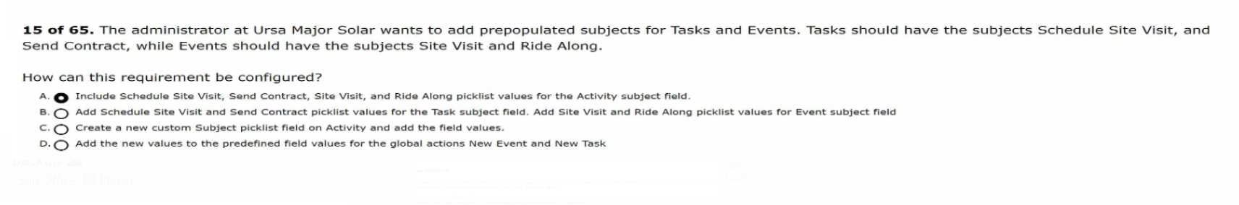
related lists, and Chatter feeds to each appear on separate tabs when viewing an Account.
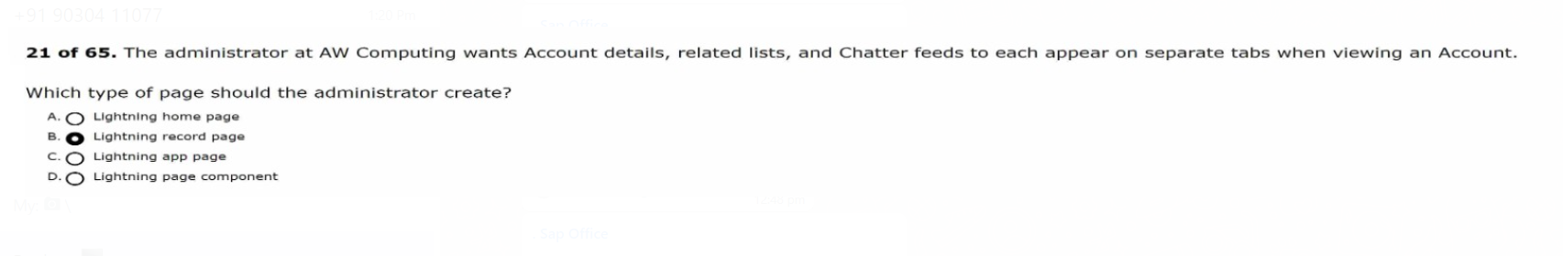
The support manager would like to automate this process, as too many reps are forgetting this step.
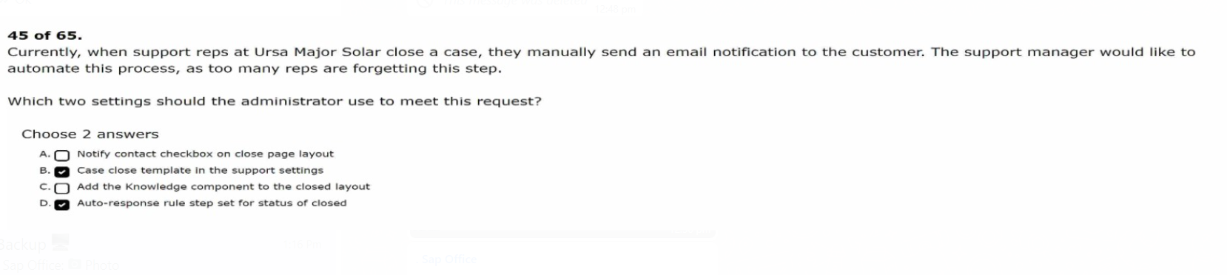
Salesforce org for its service team and would like to know what Objects Will be made available With out Of the box Service Cloud.
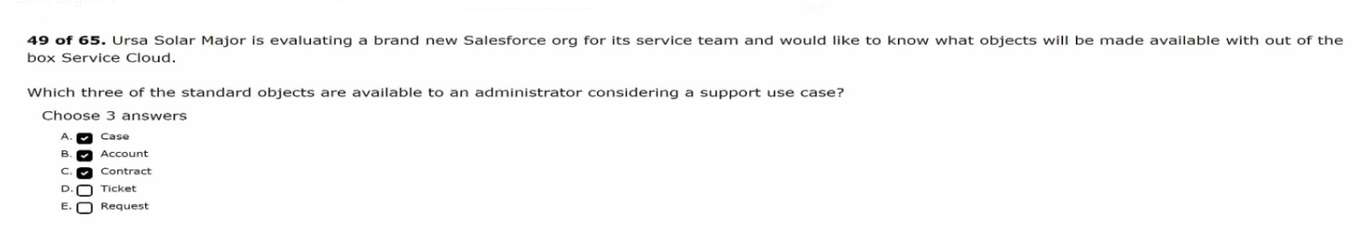
What is the order of execution when a Case record is saved?
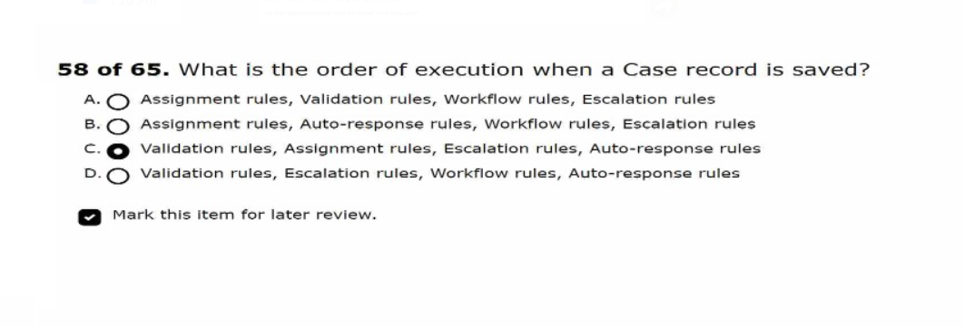

A customer renews their warranty for another three years.
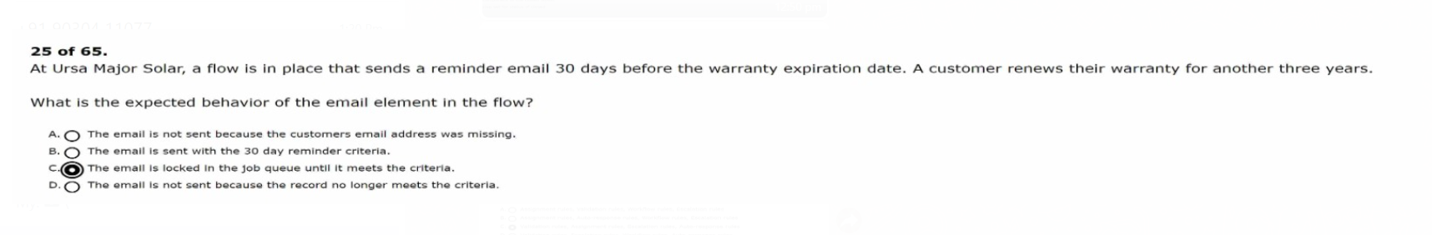

to the customers when the case subject contains the words forgot and password.
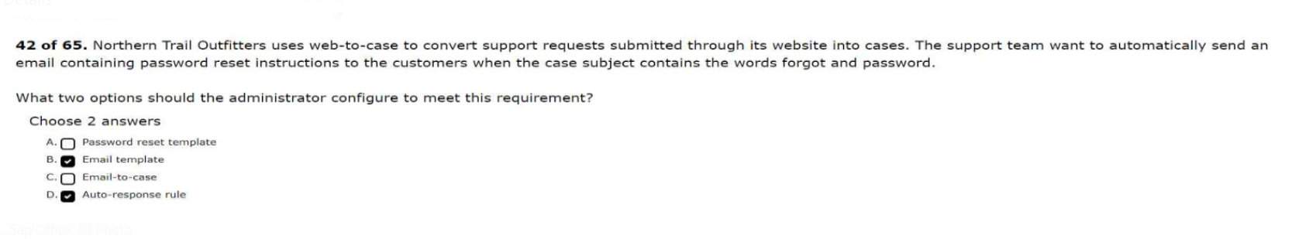
mobile app can the administrator customize the branding?
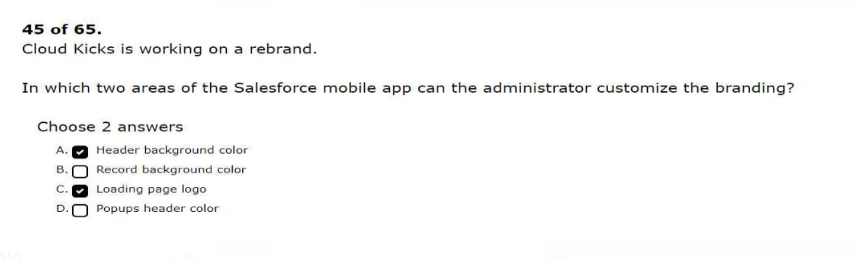
with their team in Chatter but currently do not have access to this capability.
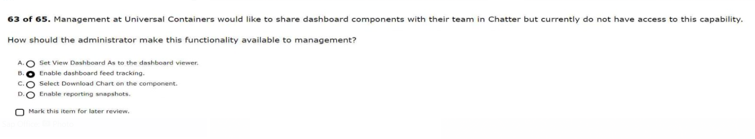
The administrator attempted the same edit without receiving an error.
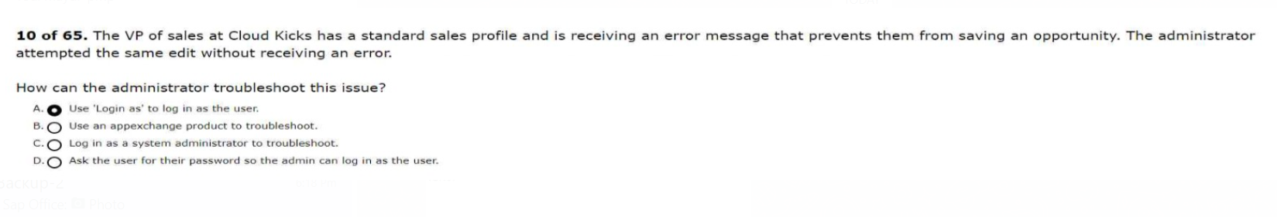
the New Status after 4 hours must be escalated to support management.
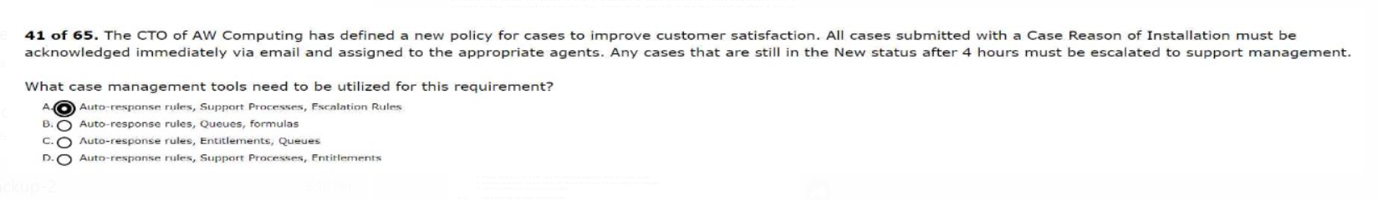
when they close an opportunity as won, and another task after 60 days to check in with the customer.
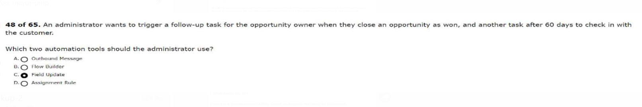
from outside of their network.
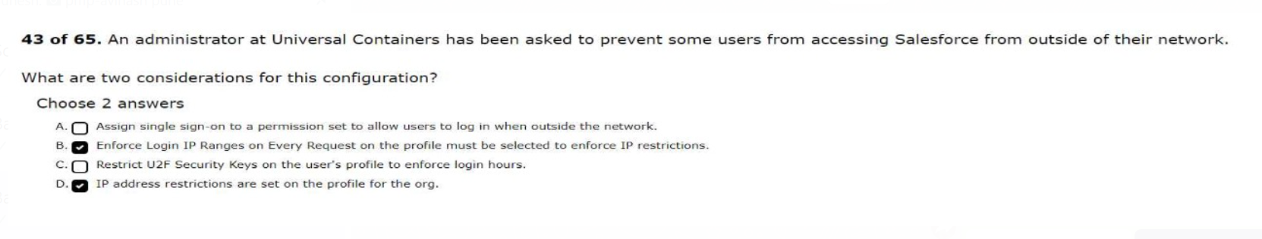
for a given product on the product record.
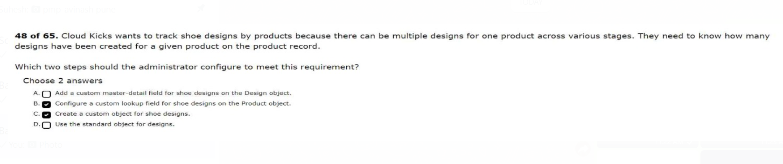
from an application external to Salesforce.
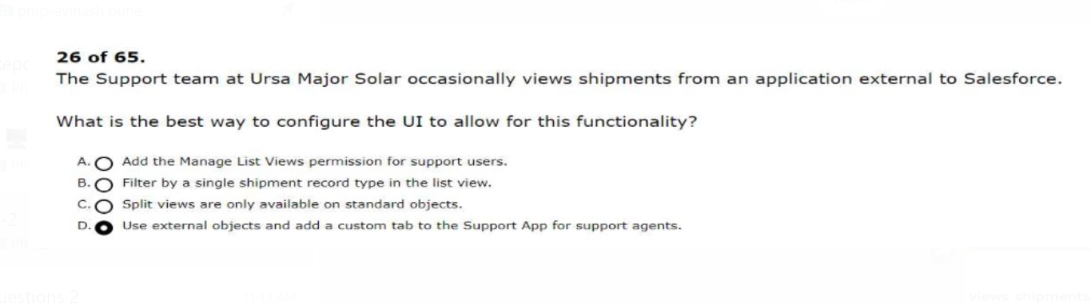
component to show the status of the check-ins.
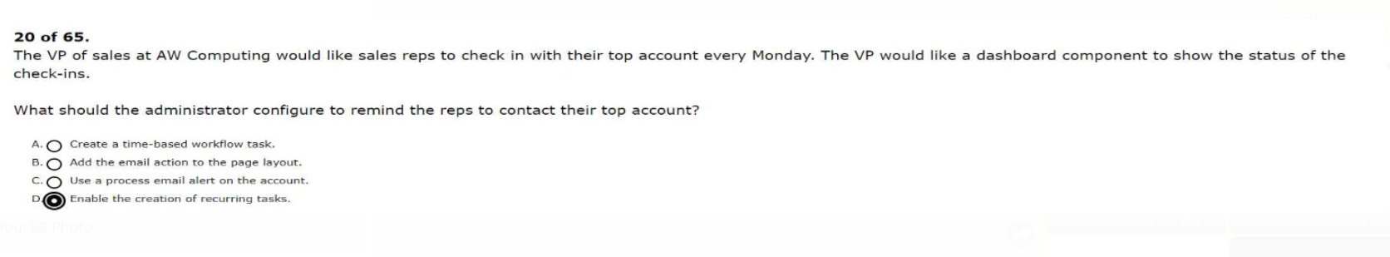

to be restored to the page layout

from their data warehouse.
